Dannevirke South School

Charter and Strategic Plan
2019

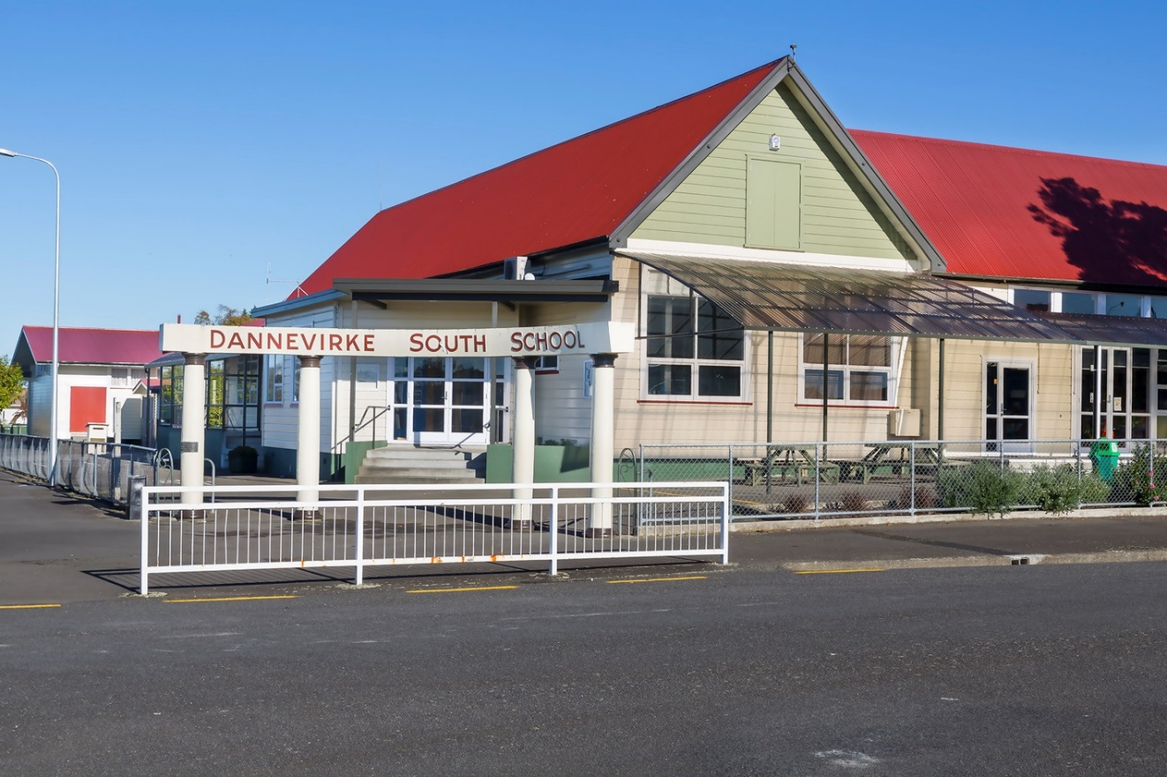
Contents

Mission, Values and Guiding Principles
School Environment
Aspirations 21st Century
Cultural Diversity
Strategic Priorities Review 2019 - 2023
Annual Plan 2019
Student Achievement Targets and Interventions 2017
Supporting Documentation
- Play Based Learning 3 Year Plan
- Year 7 & 8 Flexible Learning Environment Journey
- KiVa Anti-bullying 2019 Plan

Inspiring Growth, Passion and Success
Values | Respect  Whaka-ute | Caring  Manaaki | Honesty  Pono-nga | Confidence  Maia | Excellence  Tino Pai-rawa | Courtesy  Whakaaro-awhai
Guiding Principles | The Principles of the New Zealand curriculum are the foundations of decision making at Dannevirke South School | High Expectations | We monitor student progress as achievement. Students are encouraged to develop excellence through personal goal setting and monitoring. The curriculum reflects this and ensures there is opportunity for achievement. Our process of self-review ensures teachers are monitoring achievement.
 |  | Treaty of Waitangi | Dannevirke South School acknowledges this as a foundation of Aotearoa New Zealand. Learning in Te Reo and Tikanga Maori by incorporating this into learning programmes.
 |  | Cultural Diversity | Through the teaching of inquiry based big ideas the cultural diverse nature of our country is acknowledged. Through the implementation of our curriculum all students have the opportunity to develop respect for others.
 |  | Inclusion | All students are provided with the best possible opportunities to learn. Our curriculum acknowledges and reflects diversity and provides opportunities for differences to be catered for.
 |  | Learning to Learn | At Dannevirke South School all students are encouraged to reflect on their own learning. This is done through goal setting and the self-assessment process. Teachers develop their pedagogy through teaching as inquiry.
 |  | Community Engagement | Our curriculum is designed with the need of our local community in mind. It is meaningful and connects to the prior knowledge and experiences of students.
 |  | Coherence | At Dannevirke South School we offer all students a broad curriculum. Links are made between all learning areas and key competencies developed.
 |  | Future Focus | Our curriculum encourages students to look to the future. Through our big ideas students are able to explore concepts that are meaningful to them setting them up for a successful future.
School Environment | The school’s vision statement and guiding principles describe the type of learning environment we want South to be. Our school community works at all times to provide an environment that is safe, caring, challenging, encouraging and supportive of every individual and their needs, skills and abilities.  We encourage every individual to strive for their personal best in everything they do at South School. We expect high standards and celebrate success across all spheres of learning and endeavour.  Our school’s values are at the heart of this environment. Students are encouraged and supported to ‘live’ the values in everything they do.
Aspirations for the 21st Century | For students to be  successful and productive in the 21C they will need to: |  | - Be effective communicators  - Be successful in Numeracy & Literacy  - Have technological capabilities  - Be exposed to a wide range of highly motivating learning opportunities across a range of New Zealand curriculum areas  - Be self-motivated and take responsibility for their own learning  - Think logically and critically and be creative and innovative  - Appreciate the contribution that cultural diversity makes to our school community & society  - Understand, model and live the agreed school wide values  - Acknowledge and show understanding of the Treaty of Waitangi, te reo Maori & tikanga Maori  - Understand, model and live the agreed school wide values
Cultural Diversity | The Board of Trustees and the South School learning community recognises the cultural diversity of New Zealand through the integration of te reo Maori (Language) and tikanga Maori (culture) into all curriculum areas.  The Board is currently unable to provide te reo Maori in a bilingual or an immersion setting but will consider all requests for instruction in te reo Maori on a case by case basis and in light of current resourcing and capabilities at the time.  Regular inclusion of greetings, social phrases, names for classroom objects and instructions by teaching staff in daily lessons, Iwi led te reo classes and Kapa Haka will ensure students familiarity and acceptance of te reo Maori and tikanga Maori as part of our bi-cultural heritage.
Review | A full review of the Charter was completed with the community in 2018. The Board of Trustees reviews the Charter annually and undertakes consultation concerning specific areas where necessary. The 2018 comprehensive review tool, Rongohia te Hau, included surveying students, whanau and staff. The review has had a significant impact on direction, and revised goals, to meet the needs of our students, community and staff.

Strategic Priorities
2019-2023
- Māori language, culture and identity
At South School we celebrate our culture and unique identity within Aotearoa. We will support Te Reo Māori and improving the use of our language.
We will:
- Grow and support the development of Te Reo Māori learning for all Tamariki
- Develop understanding of our cultural history with our Tamariki
- Develop relationships with our iwi to facilitate cultural opportunities
Use the:
- Rongohui te Hau tool to continually develop and review our pedagogy to make a difference for our tamariki
- Raise achievement for identified priority learners
We will work collaboratively to ensure teachers, tamariki and whanau understand learning expectations and student progressions.
There will be high expectations for all students.
We will:
- Develop a system of showing progressions for all students that is manageable for teachers
- Teachers work in collaborative teams to identify priority learners early and plan and monitor interventions.
Collaborative teams will be guided by the following questions:
a) What is it we want our students to know and be able to do?
b) How will we know if each student has learned it?
c) How will we respond when some students do not learn it?
d) How will we extend the learning for students who have demonstrated proficiency?
- Regular communication with whanau about student expectations and progressions, particularly priority students
- Planned interventions are implemented where necessary

- Inquiry into our practice is the norm.
- All students will be provided opportunities to demonstrate their abilities across the NZC. Gifted and Talented students will be identified and provided opportunities to excel.
At South School we will develop a curriculum that meets the needs of all our tamariki. We will be innovative. Gifted and Talented tamariki will be identified early and provided opportunities that enable them to use their talents.
We will:
- Continue to develop and review a localised curriculum and assessment process
- Innovative programmes are planned and reviewed regularly
- Teams collaborate to develop curriculum programmes
- Tamariki and whanau provided opportunity to have a say in curriculum development
- A yearly Gifted and Talented programme is developed
- Student Transition is seamless upon entry, across year groups and when leaving South School.
At South School we recognise how successful transitions contribute towards Tamariki achievement.

We will:
- Ensure successful transition between ECE and School through our School Process and the Teacher Led Innovation Fund Project (TLIF)
- Recognise the importance of Play Based Learning in successful transitions
- Develop tamariki pathways, including signposts, across year groups
- Implement the Flexible Learning Environment Plan for Year 7 & 8
- Implement the Kahui Ako Transition to High School Programme
- Strengthen Collaborative Teaching Teams
We recognise that we must work collaboratively to improve the teaching and learning for our staff and students.
We will:
- Provide Professional Development for leaders and teachers on working effectively as collaborative teams
- Regular review of collaborative processes with staff
- Provide time for teams to collaborate

Strengthen Senior Leadership Team
We recognise that our leaders need to be effective leaders of collaborative teams and provide leadership in various areas of the school.
We will:
- Provide appropriate Professional Development
- Leaders participate in robust performance management and that this process is manageable
Improved Student Well-being
We recognise that our tamariki must feel good about themselves as a member of our school community. They must see that they can contribute in a positive way to the life of our school.
We will:
- Listen to our tamariki
- Collect appropriate data: Rongohia Te Hau, Me and My School
- Develop action plans to address areas for improvement. These plans will be reviewed with our tamariki
- Continue to implement the KiVa Anti-Bullying programme
- Develop a yearly plan to address attendance identified issues/trends in the data

